

**Sukkur Institute of Business Administration University**

Department of Electrical Engineering

**Electrical Machines- Fall 2022**

**Semester Project Fall - 2022**

**Project Name**

**Control the speed of dc motor with Arduino:**

Group Members:

**1. Wakeel Ahmed.**

**2. Bhai Khan.**

Instructor: **Dr: Qasim Ali**

Certificate

*It is certified that Mr.* ***Wakeel Ahmed*** *and* ***Bhai Khan*** *having CMS ID’s* ***(033-19-0026) (033-19-0015)*** *are the students of* ***BE- V*** *have carried out the “****Semester Project****” for the subject* ***of Electrical Machines*** *as provided by the Instructor of the subject at the department of Electrical Engineering, Sukkur Institute of Business Administration for* ***Fall - 2022.***

Date: 8/12/2022 Instructor’s Signature

**Table of Contents**

1. Introduction:
2. Components:
3. Schematic:
4. DC motor:
5. Working principle:
6. Code:
7. Conclusion:
8. References:

**Abstract:**

When have seen an unprecedented transition after the industrial revolution. In this era technology, the human standard of living has been totally changed, even now we are working on a human expedition to Mars. All of this is achieved through a disruptive and innovative approach to software and hardware.

Keeping in mind above transition and its need, we decided to our learned skills effectively on hardware logic. Arduino near to us is a basic building block for our good design thinking.

Our "DC motor speed control" is based on Arduino uno, where Arduino uno operate to control the rpm of the motor.

1. **Introduction:**

In this project, we will show you how to achieve Speed and Direction Control of DC Motor using Arduino UNO. It is a simple project using Arduino UNO and a few easily available components to control the speed of rotation of a DC Motor and also it direction of rotation. DC motors are used everywhere in small projects where some movement is required and also in different toys of the children DC motor is a actuator that convert dc supply to motion or movement.

Generally, when a DC motor is associated with any microcontroller based system, it is often connected using a Motor Driver IC. A Motor Driver IC provides the necessary current for the motor to run. It can also control the direction of the rotation.

In this project we are designing arduino based speed and direction control of motor without an IC required.

1. **Components Required:**

|  |  |
| --- | --- |
| Components | Quantity |
| 270 ohm resistor | 01 |
| Arduino uno | 01 |
| PN2222 Transistor | 01 |
| 1N4001 Diode | 01 |
| Bread Board | 01 |
| Connecting Wires | As required |

1. **Schematic:**

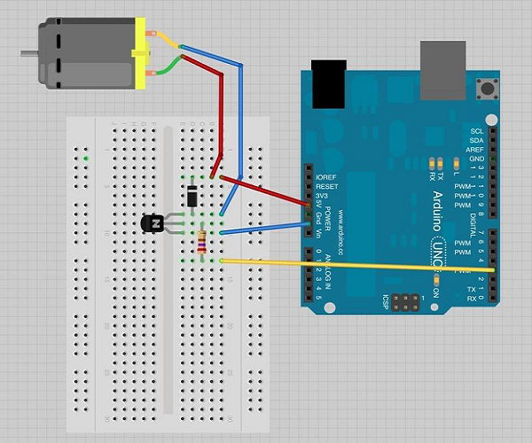

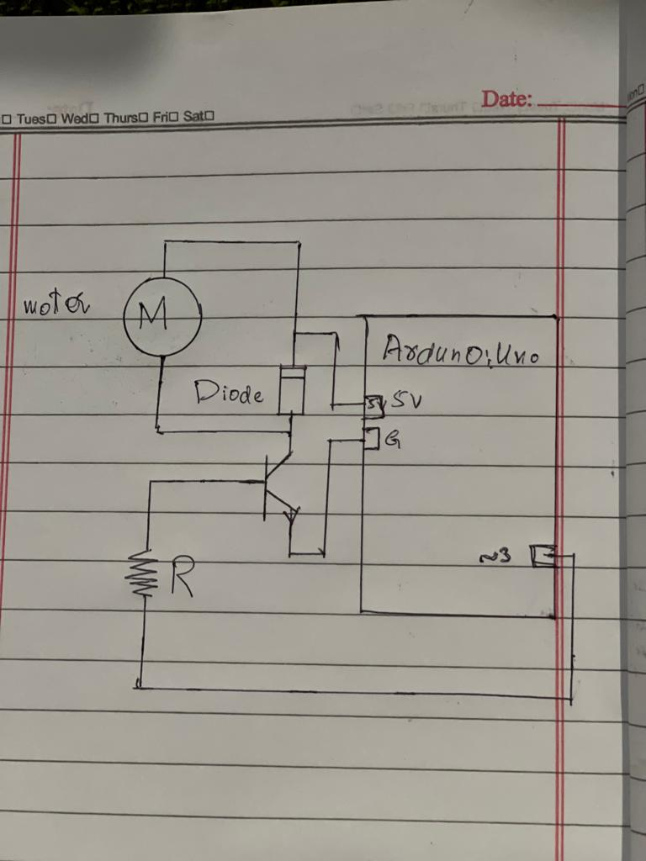

* **Precautions:** Take care of the following precautions while making connections.
  + Flat side of transistor should face to Arduino as shown.
  + The striped end of the diode should be towards the +5V power line according to the arrangement shown in the image.

1. **DC Motor:**

A DC motor (Direct Current motor) is the most common type of motor. DC motors normally have just two leads, one positive and one negative. If you connect these two leads directly to a battery, the motor will rotate. If you switch the leads, the motor will rotate in the opposite direction.

1. **Working Principle:**

In this project we have focused on two areas given below.

* Just spin the motor.
* Control the speed.

To make the motor just spin or rotate. We have connected transistor with arduino uno digital pin 3. That pin is used to turn the transistor on and off. We are using in the code digitalWrite because output is 1 or 0. And in the result motor will spin in full speed when digital pin 3 goes high.

To control the speed of the motor, all we need to do is to replace digitalWrite function on Arduino enable pins to analogWrite. The speed of the motor depends on value that was passed to the analogWrite function. Remember the value can be between 0 and 255. If you pass 0, then the motor will stop and if you pass 255 then it will run at full speed. If you pass a value between 1 and 254, then the speed of the motor will vary accordingly. In this connection Transistor is connected to pin 3 on arduino.

1. **Code:**
2. **Spin control:**

int motorPin = 3;

void setup() {

}

void loop() {

digitalWrite(motorPin, HIGH);

}

1. **Motor speed control:**

int motorPin = 3;

void setup() {

pinMode(motorPin, OUTPUT);

Serial.begin(9600);

}

void loop() {

analogWrite(motorPin, 30);

}

1. **Conclusion:**

In this project we concluded that we can spin the DC motor on the principle of on and off from the digital pin 3 of the arduino to the transistor. We the pin3 of the arduino is high the motor will spin or rotate with full speed according to supplied power. When the pin 3 on arduino is low motor will stop. In order to regulate the speed of motor from 0 to 255 or in between we can amend the program and take from the user a value from 0 upto 255. If user input 0, then motor will not rotate. If user inputs 255 then motor will rotate at full speed. And the values in between, then motor will rotate accordingly.

We can also change the direction of motor if we are using L298 motor driver IC or H- bridge circuit, togather with our circuitary.

1. **References:**

[**https://www.tutorialspoint.com/arduino/arduino_dc_motor.htm**](https://www.tutorialspoint.com/arduino/arduino_dc_motor.htm)

[**https://www.slideshare.net/mafazahmed/speed-control-of-dc-motor**](https://www.slideshare.net/mafazahmed/speed-control-of-dc-motor)

[**https://www.electronicshub.org/speed-and-direction-control-of-dc-motor-using-arduino/**](https://www.electronicshub.org/speed-and-direction-control-of-dc-motor-using-arduino/)